Moment of a force
The tendency of a force to rotate a body about an axis is known as the moment of the force about that axis. Consider the case of a force $F$ applied to the wrench to turn a nut about the $z-axis.$
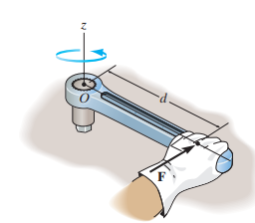 | 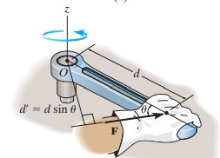 | 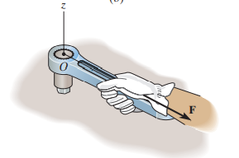
The magnitude of the moment is directly proportional to the magnitude of $F$ and the perpendicular distance or moment arm $d$. If the force $F$ is applied at an angle $θ≠90°$, then it will be more difficult to turn the bolt since the moment arm $d’=d\sin{θ}$ will be smaller than $d$. If F is applied along the wrench, its moment arm will be zero since the line of action of the force intersects with the z-axis. Hence the moment of F about z-axis is zero. If the line of action of the force is parallel to the axis, then also the moment of the force is zero.
The direction of the moment is given by the right-hand rule. The moment is considered positive if it is acting counter-clock wise. | 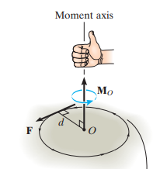 |  | 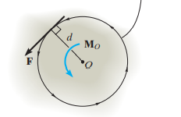
Moment of the force $F$ about the axis passing through O and perpendicular to the plane can also be expressed as the cross product, $\vec{M_{o}}=\vec{r}×\vec{F}=\left|\begin{matrix}\hat{i} & \hat{j} & \hat{k} \\ r_{x} & r_{y} & r_{z} \\ F_{x} & F_{y} & F_{z}\end{matrix}\right|$  $\vec{r}$ is the position vector of any point A on the line of action of the force.  $$\vec{r}=r_{x}\hat{i}+r_{y}\hat{j}+r_{z}\hat{k}$$  $$\vec{F}=F_{x}\hat{i}+F_{y}\hat{j}+F_{z}\hat{k}$$ |  | 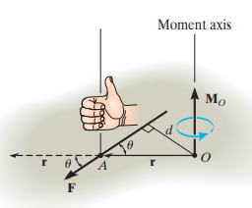

Example 1  Determine the net moment of the forces about the z-axis passing through O. | 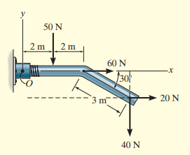
Moment of $50 N$ force about z-axis through O, $M_{1}=-50×2=-100 Nm$
Moment of $60 N$ force about z-axis through O, $M_{2}=0$
Moment of $20 N$ force about z-axis through O, $M_{3}=+20×3\sin{30}=+30 Nm$
Moment of $20 N$ force about z-axis through O, $M_{4}=-40×(4+3\cos{30)}=-264 Nm$
The net moment of the forces about the z-axis passing through O, $ΣM=-334 Nm$

Example 2  Determine the moment of the force about O. |  | 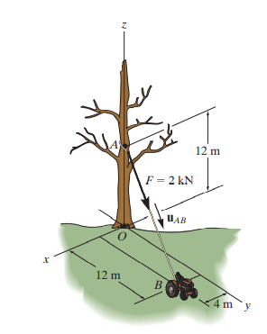
$$OB=\sqrt{{12}^{2}+4^{2}}=12.65 m$$  $$\tan{θ}=\frac{OB}{OA}=\frac{12.65}{12}≫≫ θ=46.5°$$  $$M_{o}=F×OC=F×12\sin{θ}=2×12\sin{46.5}=17.4 Nm$$ | $$F$$  $$θ$$  $$O$$  $$A$$  $$B$$  $$F$$  $$θ$$  $$A$$  $$C$$  $$12m$$  $$B$$  $$12.65m$$  $$O$$
$$\vec{r_{A}}=12 \hat{k} ≪≫ \vec{r_{B}}=4 \hat{i}+12 \hat{j} ≪≫ {\vec{r_{ }}}_{AB}=\vec{r_{B}}-\vec{r_{A}}= 4 \hat{i}+12 \hat{j}-12 \hat{k}$$
The unit vector along AB, $\hat{u}=\frac{{\vec{r_{ }}}_{AB}}{\left|{\vec{r_{ }}}_{AB}\right|}=\frac{4 \hat{i}+12 \hat{j}-12 \hat{k}}{\sqrt{4^{2}+{12}^{2}+{12}^{2}}}=0.2294 \hat{i}+0.688 \hat{j}-0.688 \hat{k}$
The force vector, $\vec{F}=F\hat{u}=2 kN\left\{0.2294 \hat{i}+0.688 \hat{j}-0.688 \hat{k}\right\}=0.4588 \hat{i}+1.376 \hat{j}-1.376 \hat{k} N$
$\vec{M_{o}}=\vec{r_{A}}×\vec{F}=\left|\begin{matrix}\hat{i} & \hat{j} & \hat{k} \\ r_{Ax} & r_{Ay} & r_{Az} \\ F_{x} & F_{y} & F_{z}\end{matrix}\right|=\left|\begin{matrix}\hat{i} & \hat{j} & \hat{k} \\ 0 & 0 & 12 \\ 0.4588 & 1.376 & 1.376\end{matrix}\right|=-16.5\hat{i}+5.51\hat{j} kNm$
$\vec{M_{o}}=\vec{r_{B}}×\vec{F}=\left|\begin{matrix}\hat{i} & \hat{j} & \hat{k} \\ r_{Bx} & r_{By} & r_{Bz} \\ F_{x} & F_{y} & F_{z}\end{matrix}\right|=\left|\begin{matrix}\hat{i} & \hat{j} & \hat{k} \\ 4 & 12 & 0 \\ 0.4588 & 1.376 & 1.376\end{matrix}\right|=-16.5\hat{i}+5.51\hat{j} kNm$
Magnitude of the Moment, $\left| \vec{M_{o}}\right|=\sqrt{{(-16.5)}^{2}+{5.51}^{2}}=17.4 kNm$ |  |  | 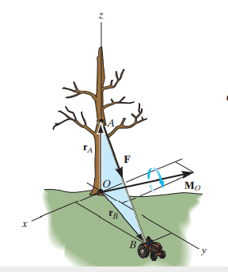

- Engineering Mechanics: Timoshenko and Young, McGraw Hill
- Mechanics for Engineers: Beer & Johnston, McGraw Hill
- Engineering Mechanics: Merriam & Kraig, Wiley
- Engineering Mechanics: Hibbeler, Pearson

